**Master’s Degree in Computer Science**

**Academic year 2023/2024**

**RoomFinder**

A report for the Mobile Programming and

Multimedia Project

|  |  |
| --- | --- |
| Authors | Student ID |
| Michael Amista’ | 2122865 |
| Sebastiano Sanson | 2130917 |

**Index of contents**

1 The project 3

1.1 Mobile app 3

1.2 Users segment 3

2 Mobile Design 4

2.1 Mockups 4

2.1.1 Nonregistered user 4

2.1.2 Registered user (Student) 9

2.1.3 Registered user (Host) 12

# **1 The project**

This project has been developed for the Mobile Programming and Multimedia course and it consists in the development of a mobile application using a cross-platform development approach to optimize the writing of the code for both Android and iOS platforms.

This section presents the idea of the mobile app, considering the contribute it can bring through people, and the kind of users who can retain the developed app a useful and effective tool for their daily life.

## **1.1 Mobile app**

Students who want to move to another city for study reasons should have the possibility to examine in a simple way all the rental proposals of the city without making a lot of calls or passing through a lot of rental agencies. This represents something that is missing in the largest Italian cities and that is the reason behind the idea of the chosen application.

The original idea of **RoomFinder** was to develop an app that allows the Italian student community, composed by both national and international students, to easily review all the rental proposals of the various accommodations scattered around the city of studies. The user can examine the various proposals by comparing prices, location and using all the other metrics offered by the app and useful for a particular facility of interest. A further important aspect is the possibility of being able to consult the possible roommates already present through a short description which will inform the user, who is carrying out the search, about the kind of persons he will meet choosing that facility. It will also be possible to engage in a chat with the host of the possible facility with the aim of exchanging useful information for both parties.

## **1.2 Users segment**

The application represents a useful tool for multiple kinds of users. In fact, RoomFinder is not only a useful tool for students who are looking for an accommodation but even for private hosts who want to make available their spaces. RoomFinder represents also an effective solution for international students who can encounter difficulties in interacting with people who only talk Italian. In fact, the application is available in both Italian and English version to extend RoomFinder’s users segment.

In RoomFinder there are three types of users:

1. **Nonregistered users**: visitors that are not subscribed to RoomFinder. This kind of user can view all the rental proposals present in the system but to access to further features the subscription is necessary.
2. **Registered users**: registered students who are looking for an available and affordable facility. This kind of user can view all the rental proposals present in the system and he can access to further features that can power up his/her user experience. Some of these features are the possibility to save ads, chat with a host to request more information and view the roommates’ details.
3. **Registered Hosts**: registered owners of facilities present in the system. This kind of user can add new ads in the system and/or manages ads already added. Hosts can also respond to requests of information from students via a chat system.

# **2 Mobile Design**

The main RoomFinder pages have been designed using Figma tool. That tool allowed us to easily design pages, considering the mobile design principles seen during lessons, rather than directly code the pages.

The mockups and all the mobile design choices are discussed in this section.

## **2.1 Mockups**

Before starting to design the mockups we had to decide the color palette for the application. Considering that colour theory is a complex theme that interacts also with emotional design and cultures, we decided to make deeper research before choosing the main color and its variations for the palette. What we have found is that **color** **blue** conveys trust, calmness, professionalism, and inclusivity, all of which are crucial for an app aimed at helping students find reliable accommodations in a new city. The emotional comfort and broad appeal of blue can significantly enhance user experience, making the app a trusted and preferred tool for our users segment. This guided us to the choice of a blue palette for the entire application.

After that we produced different mockups for the main pages of RoomFinder, dividing them based on the type of user who is using the app. All the pages respect the **just-in-time principle**, showing only the elements that are necessary for that page.

### **2.1.1 Nonregistered user**

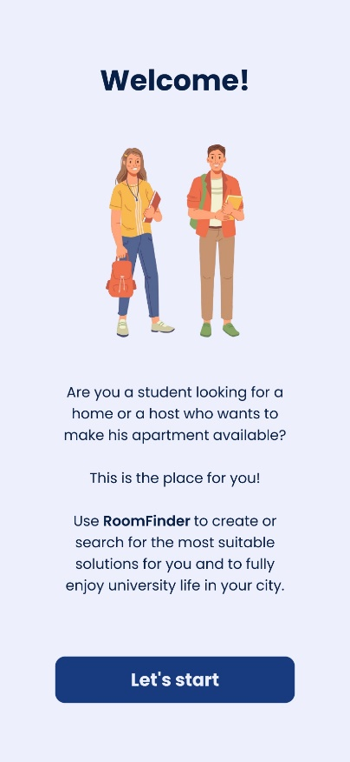**FIRST VISIT**

This page is the first one every user will see the first time he/she runs RoomFinder. The idea is to transmit a message to capture the user curiosity through the **humanization**, involving the user through a humanized figure that represents happiness, calmness and trust of students like him/her that found their stability using RoomFinder.

Furthermore, there is a written message that encourages students and hosts to use or be part of the RoomFinder network.

At the end the user, if he is convinced, is ready to start the experience through a tap on “*Let’s start*” button which redirects the user to the rental proposals search page where, ideally, a small tutorial on how to use the app is shown.

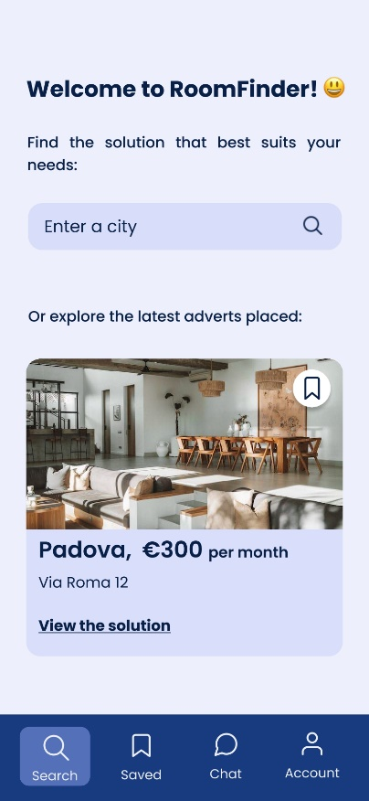**RENTAL PROPOSALS SEARCH**

After watching the short tutorial on how to use the app, the user lands on the rental proposals page, the homepage of RoomFinder, where he can search offers for a particular city of interests or explore some of the latest inserted adverts. The layout of the page is simple and gives to the user all the information and instructions it needs to begin the experience in RoomFinder. The above part of the page allows users to search for facilities located in the digited city and the rest of the page is dedicated to show to users some of the latest ads. Users can view more details for a single insertion by clicking anywhere inside the insertion box or more intuitively by clicking on “*View the solution*”. Furthermore, it is even possible to save insertions of interest by clicking on the top right corner button of each insertion box. This functionality is reserved to only registered users, but the idea is to show to the user all he can do in the application and then, when he tries to use a functionality that requires a RoomFinder account, redirect him/her to the login page (discussed later in the document) explaining him why.

The content of the page is easily reachable reducing the user effort. The bottom bar provides the access to all other main pages of the application, even if some of them (as saved ads, chat or account) are available only for registered users. Anyway, when the user tries to use some of these functionalities is automatically redirected to the login page.

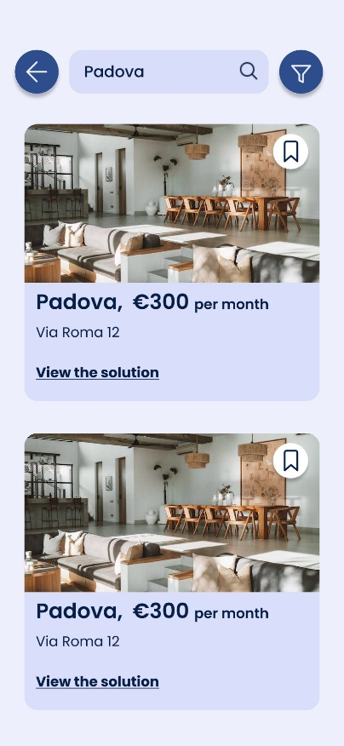**SEARCH RESULTS**

This page contains the results, so all the rental proposals, for the city searched by the user through the search functionality present in the previous page (rental proposal search). The results are presented as a list of items of the same form seen for the previous page and so with the same functionalities to open or save them.

To decrease the number of user interactions the search bar has been placed even in this page. In this way, if the user wants to search the proposals of another city, he/she can simply redigit the city in the search bar placed in the top area of the page.

It is also possible to close the page, returning so to the rental proposal search page, by using the back button placed on the left corner in order to avoid wrong taps by users.

Therefore, since the results for the searched city can be a lot, the user can filter them using a filter menu that appears through a tap on the top right icon.

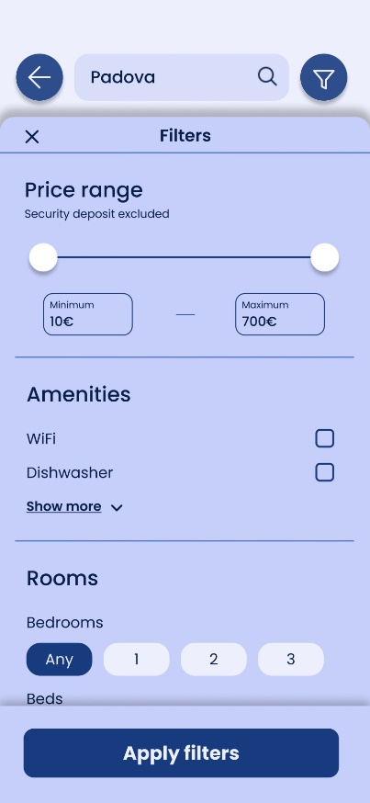**SEARCH RESULTS – FILTER MENU**

As mentioned before, the filter menu allows users to filter the search results to match their preferences for the different proposals in the system.

This menu contains several voices that can be used to search the rental proposals that match what user is looking for. At the end of the panel there is a confirmation button to search for the customized proposals.

The panel can be closed in three ways, by tapping on the top left “*X*”, tapping outside the panel itself or using a flick gesture with a movement that starts from the top area (approximately from the “Filters” voice) to the bottom of the screen. This gesture will be taught when the user tries to use the panel for the first time.

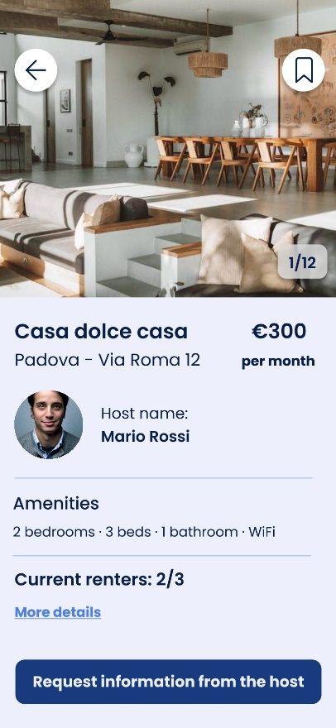**DETAILED PAGE FOR A FACILITY**

This page represents a detailed page for a facility present in the system and on which user tapped during its navigation. The page contains all the information needed to better understand what the facility offers.

In the top area we have a slider which shows some photos of the room. In general, it is true that sliders should be avoided if possible because they cause the loss of the user’s overall vision. In this case the user has full control over the slider, without the problem of annoying timers that update continuously the slide, and he can expect what comes next since it a simple slider of the facility photo. Users can move on and back the slides with a simple gesture from the left or right depending on the movement they want to do. This gesture is taught with a tutorial. Furthermore, in every moment user knows at which point of the slider he is thanks to the numbered label on the right side. In the top area there are also two other buttons, a back button on the left and another button on the right to save the insertion.

In the page there is even the possibility to open a detailed page about the current renters already present in the facility, but this is a functionality available only for registered users, so when a user taps on “*More details*”, as before, will be redirected to the login page. At the end it is possible to request further information, regarding the facility, directly sending a message to the host through the floating trigger button placed in the bottom part of the screen.

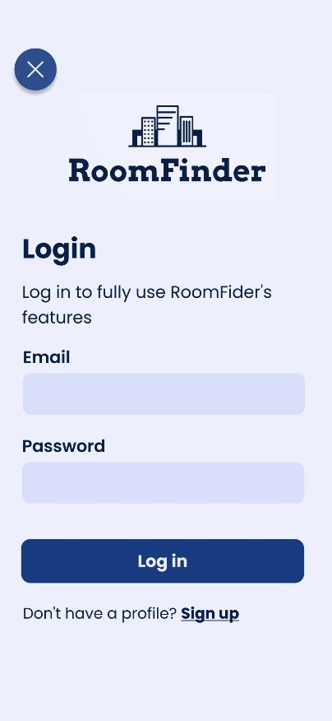**LOGIN**

This page offers the possibility to access to the RoomFinder account. Users can be also redirected to this page when they try to use a functionality not available for non-authenticated users. In this case, since the user is automatically redirect here, the page provides an explanation about the necessity to have an account to use all the functionality that RoomFinder offers.

The page is simple, and it provides a standard form to authenticate users by an email and a password. The labels for both inputs have been placed above the input to avoid that users hide them unintentionally during digiting the input.

If the user has not a profile it is possible to access to the registration page.

To avoid mistake by the user in the comfort zone, the “cancel” button, useful to close the login page and to return where the user was, has been placed in the top left corner.

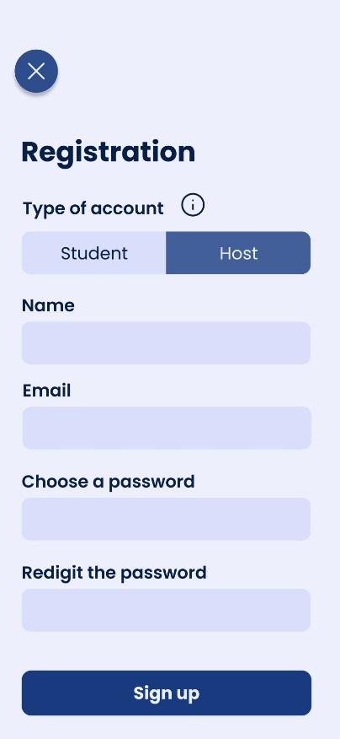**REGISTRATION**

To create a new account every user can pass through the registration page. The layout of this page is pretty much the same of the login one, so all the considerations discussed for the login page are still valid here.

The only thing that changes is the form field “*Type of account*” which is related to the purpose for which the user is creating a new account, so to be a student who is searching for a house or a host who want to publish insertions. The user has to select one of the two kinds of account by tapping on the label “*Student*” or “*Host*”. To make everything clear an info button, placed near that field, allows to obtain more information about the different types of account, ideally opening a pop-up that can be closed after everything is clear.

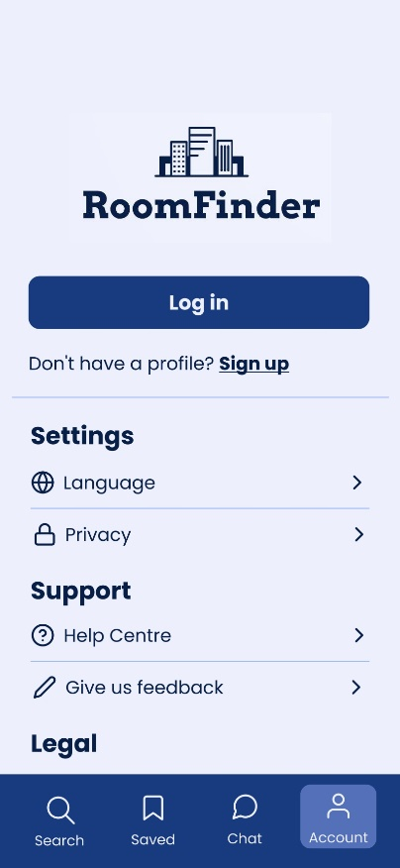**ACCOUNT**

The page contains both account and app settings. It is possible to login to RoomFinder or manages the app preferences such as the language.

The layout of the page is simple, intuitive and it tries to contain the basic elements for account and system settings present in every real application. In particular the language setting is fundamental since the users segment are both Italian and international students.

All the above pages are considered as standard pages available for both registered and nonregistered users so, if those pages do not present layout or content changes depending on the type of account, they will not be discussed anymore.

### **2.1.2 Registered user (Student)**

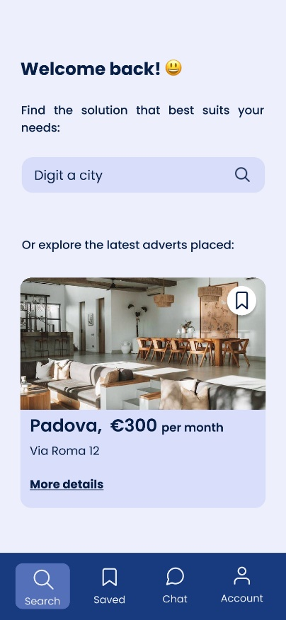**RENTAL PROPOSALS SEARCH**

The rental proposals search page is identical to the counterpart available for nonregistered users, so all the considerations made for that page are still valid for this version. The only element that changes in the content is the “*Welcome back!*” message and no more “*Welcome to RoomFinder*” that was used only as a nice message for new users.

Even the bottom menu bar is the same with the only difference that now, since the user logged in, all the RoomFinder pages and functionalities are available.

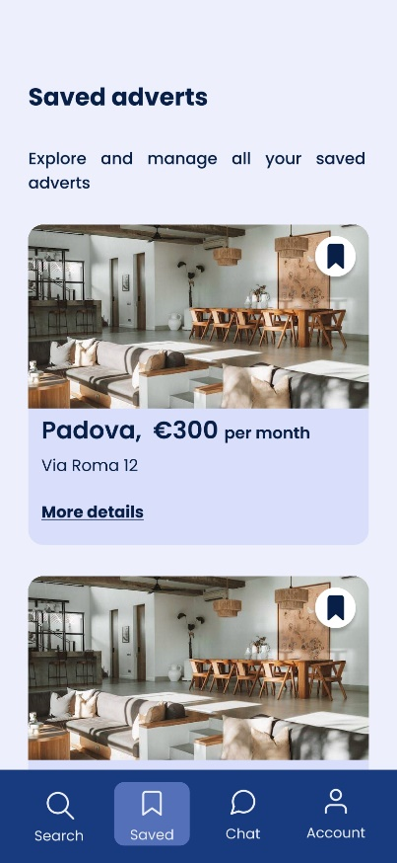**SAVED ADVERTS**

This page contains all the rental proposals saved by the user during its navigation. As mentioned before, the proposals can be saved by tapping on the save icon present on the specific proposal result or in its detailed page. Users can also remove the saved proposals by tapping on the same icon used to initially save them. The icon changes its look depending on if it can be saved or it has been already saved by replacing a void bookmark icon with a filled bookmark icon respectively. For us this approach is natural and effective, thinking also on what happens in social media apps, like Instagram, when the user put a like on a post.

Since the results list is the standard one used among all RoomFinder pages, the single saved proposals can be opened with same modalities already discussed to view the detailed page.

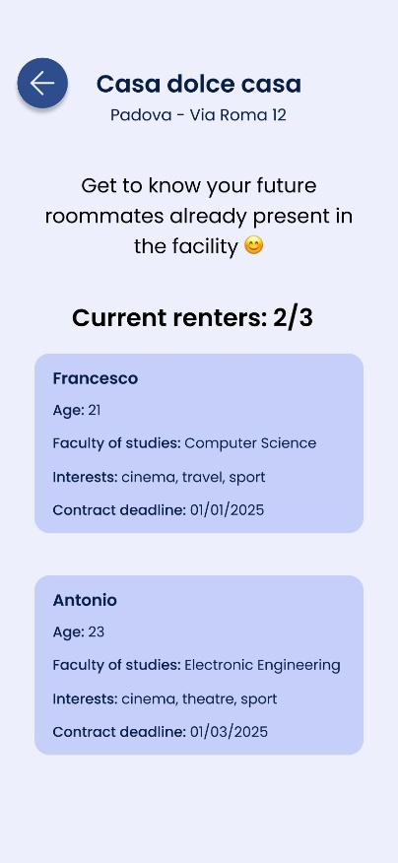**CURRENT RENTERS – MORE DETAILS**

In the detailed page for a facility, it is possible to get more information about the current renters. Only registered users are allowed to open this page.

The content is simple, and it provides a way to know better the future roommates with the user will live if he/she chooses that facility. Every roommate is represented by a box containing some general information about him/her.

It is possible to go back to detailed page of the relative facility by tapping on the left button, near which a general summary of the facility has been placed to remember user where it was before landing on this page.

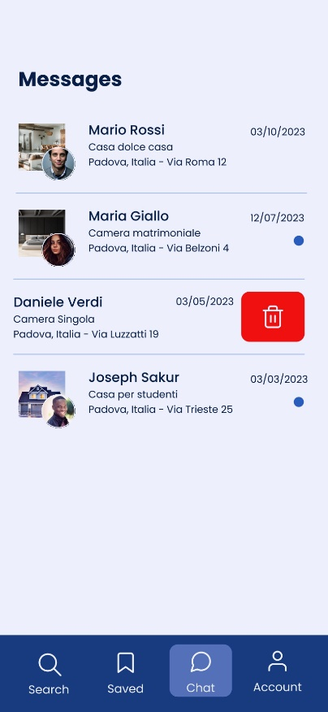**CHAT**

This page allows to manage all the messages to hosts. Messages are grouped in different chats, each one representing the request made for a specific rental proposal. New messages are highlighted by a blue circle on the right area of each chat.

It is even possible to delete old chats with a flick gesture on the specific element, starting the movement from the right to the left area of the chat itself. This gesture does not require high precision and we think that after a while it can become a sort of reflex for the user, decreasing so the required effort. This is due also to the fact that similar gestures are already used in other common application (for instance Gmail) to delete messages, so this implementation is really similar to something that users could have already seen or experimented in other scenarios. As discussed before for other gestures, this one will be taught the first time the user lands on the chat page.

Then, tapping on one chat by clicking on the whole horizontal area occupied by the each element, it is possible to view every message sent to request information about a specific rental proposal.

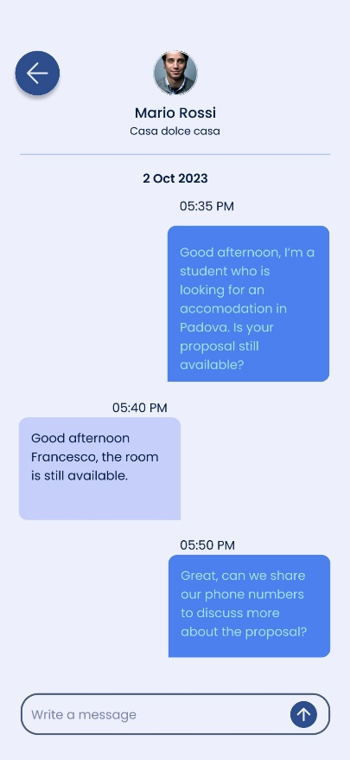**DETAILED PAGE FOR A CHAT**

The page represents the whole history of messages sent to a host regarding a facility of interest. The layout of the page is really similar to every chat application present in the market. On the right it is possible to find the student messages and on the left the host ones. It is possible to write and send a new message using the input text field on the bottom of the page.

In the top part of the page there is a short summary of the rental proposal for which the student is writing.

It is possible to go back to the chat page using the top left button.

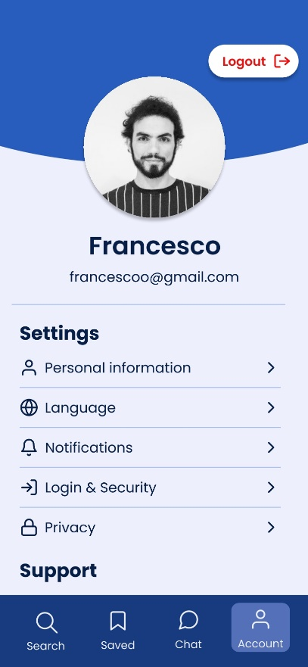**ACCOUNT**

This page allows users to view and manage their profile information. It is also possible to customize the app experience by some general settings, as discussed before for the counterpart available for nonregistered users. It is also possible to logout using the top right button which has been placed outside the comfort zone to avoid mistakes by user even if a confirmation dialog to complete the operation is however shown.

### **2.1.3 Registered user (Host)**

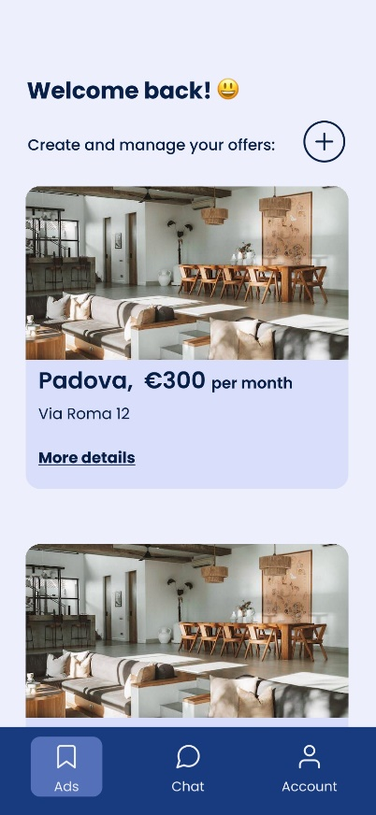**RENTAL PROPOSALS MANAGEMENT**

This page represents the first page that a registered host sees when he/she starts RoomFinder. This page allows to create and manage rental proposals that can be viewed by students who want to search for an accommodation.

The overall layout is really similar to other pages previously discussed. The host can view the whole list of his/her proposals and can add new ones by tapping on the “+” button placed on the top right area. The user can also view in detail each proposal that appears in the list tapping on the whole item box or, more intuitively, tapping on the label “*More details*”.

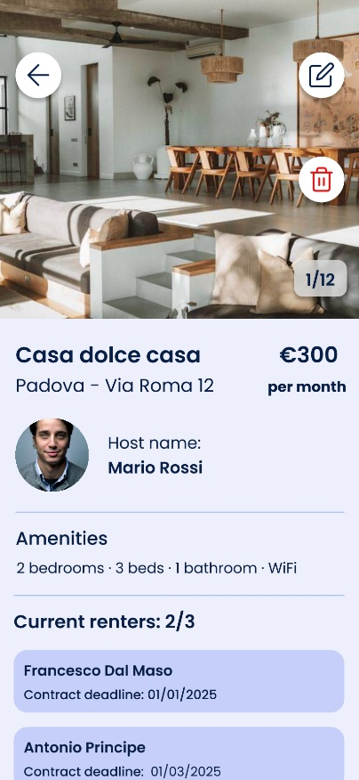**DETAILED PAGE FOR A FACILITY**

The detailed page is pretty identical to the counterpart available for other kinds of user with just a few differences. The host has two more features represented by the two buttons placed in the top right area which allow respectively to edit the proposal or to delete the proposal. Since both buttons allow to modify the page content, they have been placed outside the comfort zone to avoid wrong taps by user. Anyway, even in this case, the delete option opens a confirmation dialog that requires the user confirmation before proceeding with the elimination.

**+ PAGES FOR ADD/EDIT RENTAL PROPOSAL**